/*Ashok PBC DBA Roles Lab 7.19.19*/

Homework – Write a 2 page paper on the Database Administrator (DBA).

1. What do they do and why are they needed?

 DBA’s job is to ensure data to the application tier is performant, secure and recoverable.

Every organization that manages data using a database management system (DBMS) requires a database administration group to oversee and assure the proper usage, deployment and security of the company’s data and databases. With the growing mountain of data and the need to organize that data effectively to deliver value to the business, most modern organizations use a DBMS for their most critical data. So, database administrators (DBAs) is needed in organizations.

1. Explain the different roles and tasks of a DBA.

Below are some tasks which DBA does usually,

* DBA oversee and assure the proper usage and deployment of the company’s data and databases.
* Checking logs and keeping tabs on the SQL Server Agent
* Performance **management and** tuning database periodically for server performance
* Testing and Validating Backups AND the Ability to Restore Them when needed
* Coordinating Data Pushes, Changes and **Data movement** 
  + Ex. data pushes from staging to production server for any program or part of files
* Code Reviews for queries for better performance and Interactions with Developers for it
* **General database management**
* **Metadata management and repository usage**
* **Database schema creation and management**
* **Capacity planning**
* **Backup and recovery**
  + The DBA must implement an appropriate database backup and recovery strategy for each database file based on data volatility and application availability requirements

### **Ensuring data integrity**

### **Data security**

### **Storage management techniques** on database

1. Describe the different tools a DBA uses to administer the database?

Database administration tools provide a GUI / Web interface to automate database tasks like looking up tables, find and replace, and any other task that you may wish to run on a database. There are many tools based on type of database.

## SQL Web Data Administrator

It is a web panel that provides users with a very simple solution for performing basic database commands. It’s a really lightweight application, so user won’t see much of system resources used by this application.

## SQL Server Management Studio

SQL Server Management Studio (SSMS) is an integrated environment for managing any SQL infrastructure, from SQL Server to Azure SQL Database. SSMS provides tools to configure, monitor, and administer instances of SQL Server and databases. We can use SSMS to deploy, monitor, and upgrade the data-tier components used by your applications, as well as build queries and scripts.

## MySQL WorkBench

[MySQL Workbench](https://dev.mysql.com/downloads/workbench/) is designed for the more advanced database administrator, you are sure to find almost every database function you need inside [MySQL Workbench](https://dev.mysql.com/downloads/workbench/). It takes nearly every SQL task and brings them into a graphical user interface. It is a powerful database administration tool with visual interfaces for creating, optimizing, and executing MySQL queries.

## phpMyAdmin

[phpMyAdmin](https://www.phpmyadmin.net/home_page/downloads.php) has been the de facto standard in MySQL database administration for years. It boasts a full featured and easy to use web interface, and its cross platform and open source design makes it an attractive option for most server administrators.

d. * 3 Important Facts

DBAs also occupy a central position in the continuum of skills:

• On one hand, they have to understand a lot about how the application code works, because application developers are their customers.

• On the other hand, they need to understand how the application runs in production, because operations staff are also their customers.

• DBAs end up knowing a lot about everything, and because they can develop this all-encompassing set of skills and knowledge, the organization relies on them to do so.

What to Submit:

1. Copy and paste the link to your video(s) SQL – What is Referential Integrity homework.

<https://app.colaberry.com/app/ipbc/videos?user=31221&category=26>

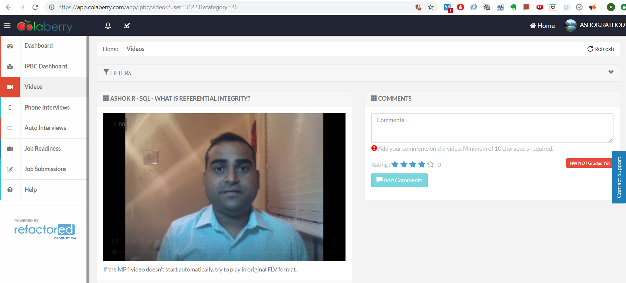

1. Watch, Comment &amp; take screenshots of your comments from 3 other videos on the same topic (per question). Comments must be 20+ characters. 